

**International School**

**Capstone Project 2**

CMU-SE 451

**User Interface Design**

**Version 1.0 Date: 20/02/2024**

Intelligence IT Job Finding - The Recruitment System support with   
Chatbot

Submitted by Tuan, Nguyen Anh

Dat, Nguyen Thanh

Duyet, Pham The

Tri, Le Minh

Approved by

Hoang, Nguyen Thai

Proposal Review Panel Representative:

Name Signature Date

Capstone Project 2 - Mentor:

Name Signature Date

PROJECT INFORMATION

|  |  |  |  |
| --- | --- | --- | --- |
| **Project acronym** | Intelligence IT Job Finding | | |
| **Project Title** | The Recruitment System support with Chatbot | | |
| **Start Date** | 15th Feb 2024 | **End Date** | 27th May 2024 |
| **Lead Institution** | International School, Duy Tan University | | |
| **Project Mentor** | Mr. Hoang, Nguyen Thai | | |
| **Scrum master / Project Leader & contact details** | Tuan, Nguyen Anh  Email: tuanquynh1111050102@gmail.com  Tel: 0975523135  ID: 26211235098 | | |
| **Partner Organization** | Duy Tan University | | |
| **Project Web URL** |  | | |
| **Team members** | Name | Email | Tel |
| 26211242012 | Dat, Nguyen Thanh | [nguyendat16111210@gmail.com](mailto:anhthang2529@gmail.com) | 0352694246 |
| 26211229940 | Tri, Le Minh | leminhtri2002@gmail.com | 0395967905 |
| 26211233669 | Duyet, Pham The | duyetpham322@gmail.com | 0705235603 |

REVISION HISTORY

|  |  |  |  |  |
| --- | --- | --- | --- | --- |
| **Version** | **Date** | **Comments** | **Author** | **Approval** |
| 1.0 | 23/03/2024 | Update interface Design Document | Tri, Le Minh |  |

1. **Introduction**
   1. **Purpose**

* This document serves the purpose of specifying application’s UI design
  1. **Scope**
* Create complete interfaces, and describe them clearly.
* Overview of the stages and modules of the system

1. **Describe User Interface Application in Detail**
   1. **UI - Candidate**
      1. **UI-01: Header UI**



1

2

4

3

|  |  |  |  |  |
| --- | --- | --- | --- | --- |
| **ID** | **Condition** | **Control Type** | **Target** | **Notes** |
| 1 | Click | Picture | Logo of web |  |
| 2 | Click | Hyperlink | open other pages |  |
| 3 | Click | Input | Enter from you want to search |  |
| 4 | Click | Button | List of 10 hottest tours |  |

* + 1. **UI-02: Footer UI**

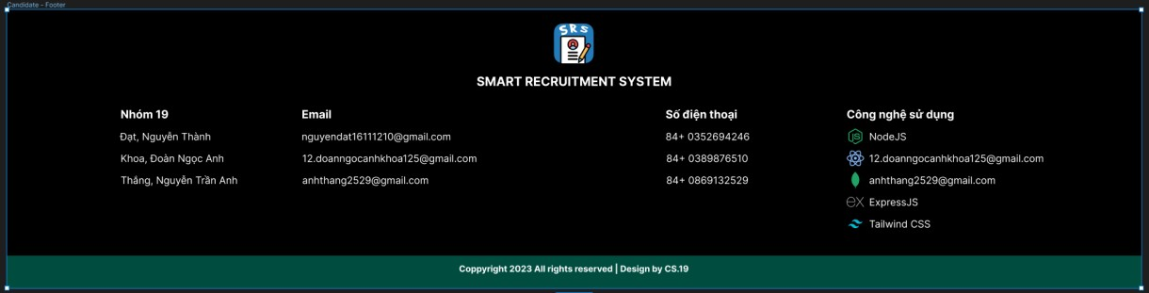

5

4

2

1

6

3

|  |  |  |  |  |
| --- | --- | --- | --- | --- |
| **ID** | **Condition** | **Control Type** | **Target** | **Notes** |
| 1 | Nothing | Picture | Logo of web |  |
| 2 | Nothing | Text | Name for Web |  |
| 3 | Nothing | Text | Name of Member |  |
| 4 | Nothing | Text | Email of Member |  |

|  |  |  |  |  |
| --- | --- | --- | --- | --- |
| 5 | Nothing | Text | Phone of Member |  |
| 6 | Nothing | Text | Technology used for the project |  |

* + 1. **UI-03: Login UI**



1

7

6

5

|  |
| --- |
| 2 |
| 3 |
| 4 |

|  |  |  |  |  |
| --- | --- | --- | --- | --- |
| **ID** | **Condition** | **Control Type** | **Target** | **Notes** |
| 1 | Nothing | Form | Form Login |  |
| 2 | Nothing | Text | Name form Login |  |
| 3 | Click | Input | Enter Email |  |
| 4 | Click | Input | Enter Password |  |
| 5 | Click | Button | Button Login |  |
| 6 | Click | Button | Button login with Google |  |
| 7 | Click | Button | Button login with Facebook |  |

* + 1. **UI-04: Register UI**

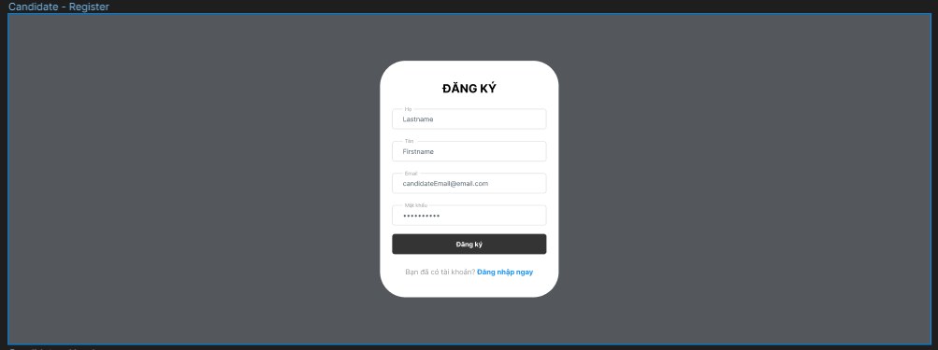

1

|  |
| --- |
| 2 |
| 3 |
| 4 |
| 5 |
| 6 |
| 7 |
| 8 |

|  |  |  |  |  |
| --- | --- | --- | --- | --- |
| **ID** | **Condition** | **Control Type** | **Target** | **Notes** |
| 1 | Nothing | Form | Form Register |  |
| 2 | Nothing | Text | Name form Register |  |
| 3 | Click | Input | Enter Last Name |  |
| 4 | Click | Input | Enter First Name |  |
| 5 | Click | Input | Enter Email |  |
| 6 | Click | Input | Enter Password |  |
| 7 | Click | Button | Button Register |  |
| 8 | Click | Hyperlink | Go to login page |  |

* + 1. **UI-05: Home UI**

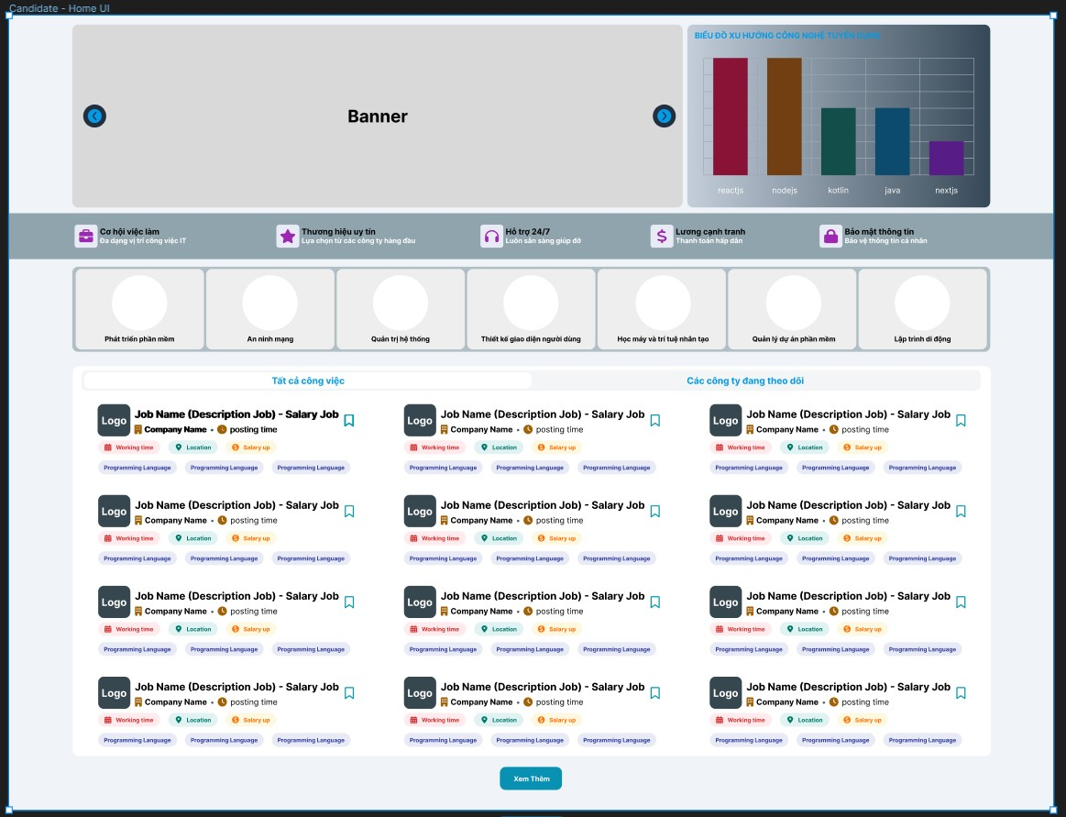

3

5

7

4

2

1

6

|  |  |  |  |  |
| --- | --- | --- | --- | --- |
| **ID** | **Condition** | **Control Type** | **Target** | **Notes** |
| 1 | Nothing | Picture | Picture Banner |  |
| 2 | Nothing | Chart | Technology trend chart |  |
| 3 | Nothing | Paragraph | Brief description |  |
| 4 | Click | Hyperlink | Type Job |  |
| 5 | Nothing | List | List Job |  |
| 6 | Click | Hyperlink | Job |  |
| 7 | Click | Button | Button see more job |  |

* + 1. **UI-06: Job Categories UI**

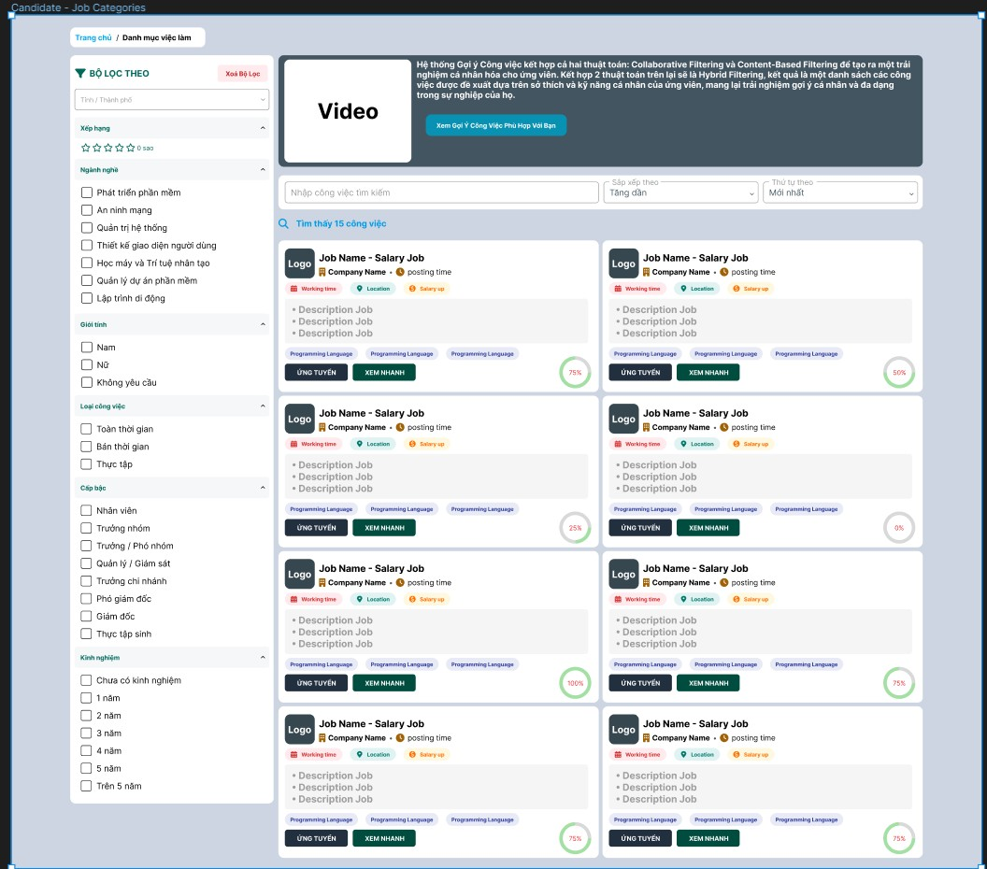

1

4

5

6

2

3

|  |  |  |  |  |
| --- | --- | --- | --- | --- |
| **ID** | **Condition** | **Control Type** | **Target** | **Notes** |
| 1 | Nothing | List | List Fillter |  |
| 2 | Click | Combo box | Fillter Search Job |  |
| 3 | Nothing | Image, paragraph | Introduction system |  |
| 4 | Click | Hyperlink | Fill Job |  |
| 5 | Nothing | List | List Job |  |
| 6 | Click | Hyperlink | Job |  |

* + 1. **UI-07: Job Detail UI**

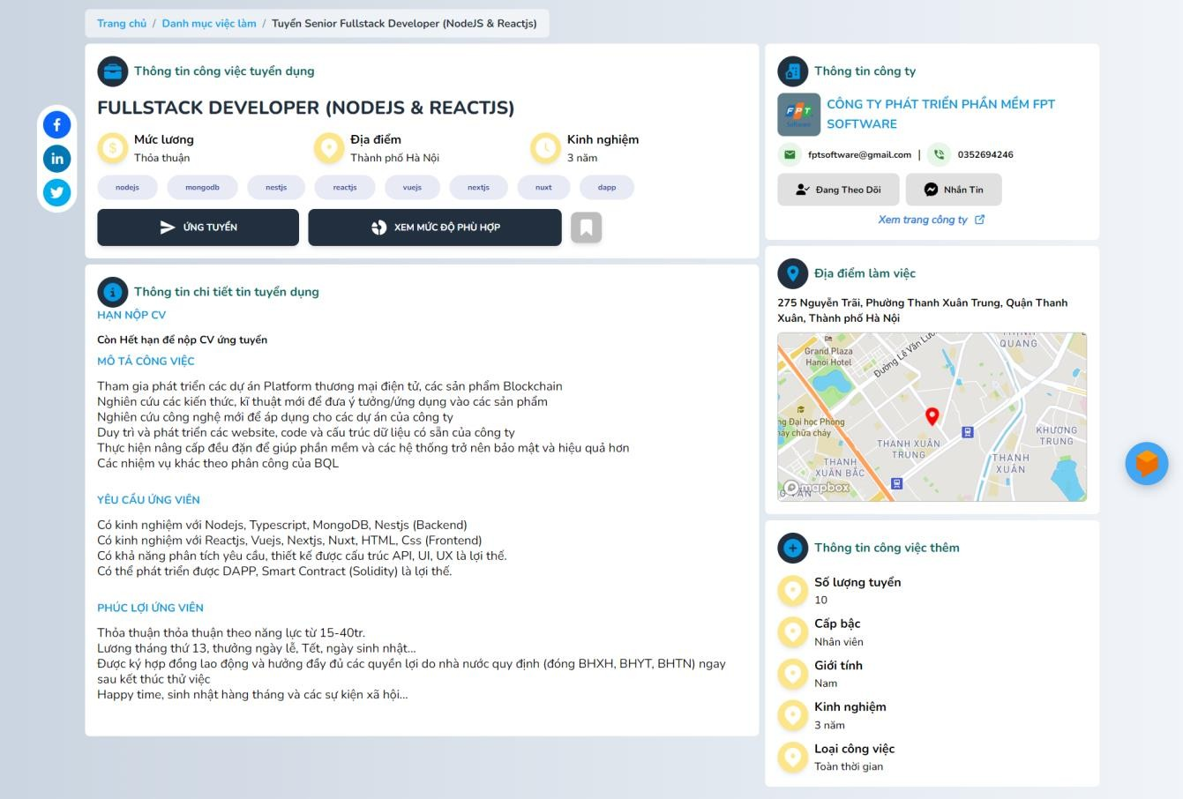

5

2

7

4

6

3

1

|  |  |  |  |  |
| --- | --- | --- | --- | --- |
| **ID** | **Condition** | **Control Type** | **Target** | **Notes** |
| 1 | Nothing | List | Information Job |  |
| 2 | Click | Button | Recruitment Job |  |
| 3 | Click | Button | Degree of suitability for the job |  |
| 4 | Nothing | List | Description Job |  |

|  |  |  |  |  |
| --- | --- | --- | --- | --- |
| 5 | Nothing | List | Information Company |  |
| 6 | Click | Map | Location Company |  |
| 7 | Nothing | List | Additional job information |  |

* + 1. **UI-08: Company UI**

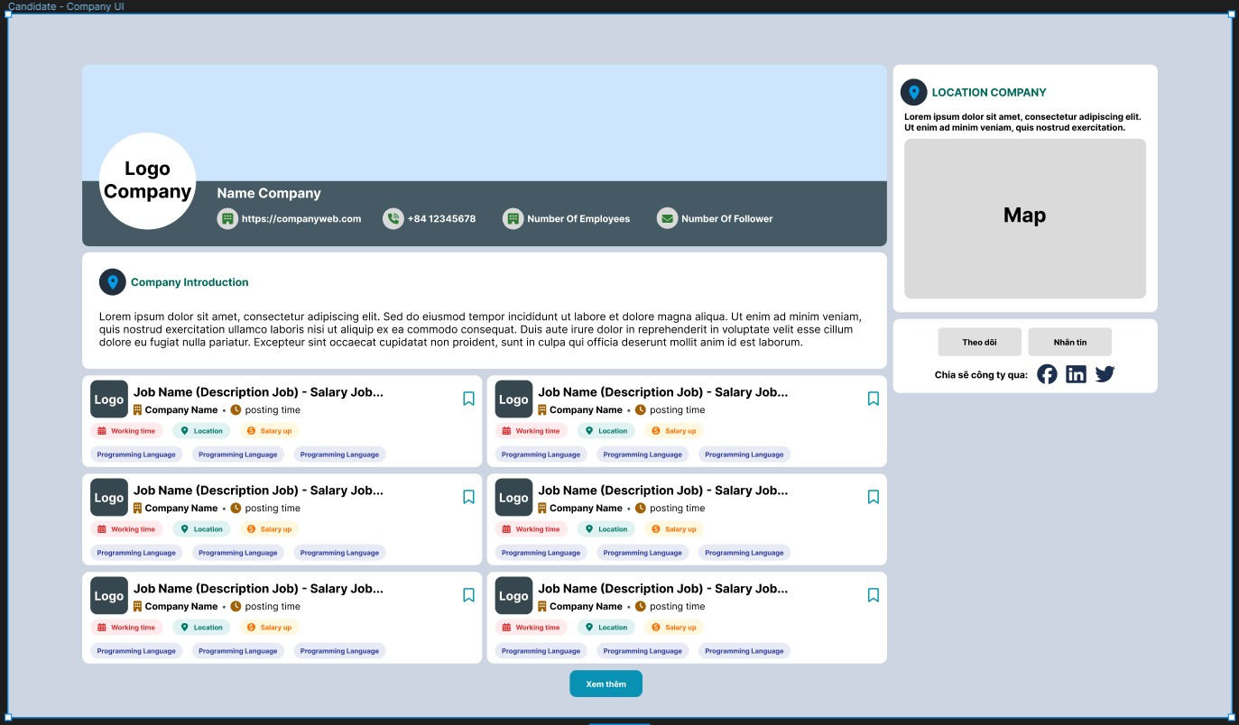

2

3

5

4

1

|  |  |  |  |  |
| --- | --- | --- | --- | --- |
| **ID** | **Condition** | **Control Type** | **Target** | **Notes** |
| 1 | Nothing | Picture | Image Company |  |
| 2 | Nothing | Text | Information Company |  |
| 3 | Nothing | List | Job List |  |
| 4 | Click | Map | Location Company |  |
| 5 | Click | Button | Social Company |  |

* + 1. **UI-09: Job Wishlist UI**

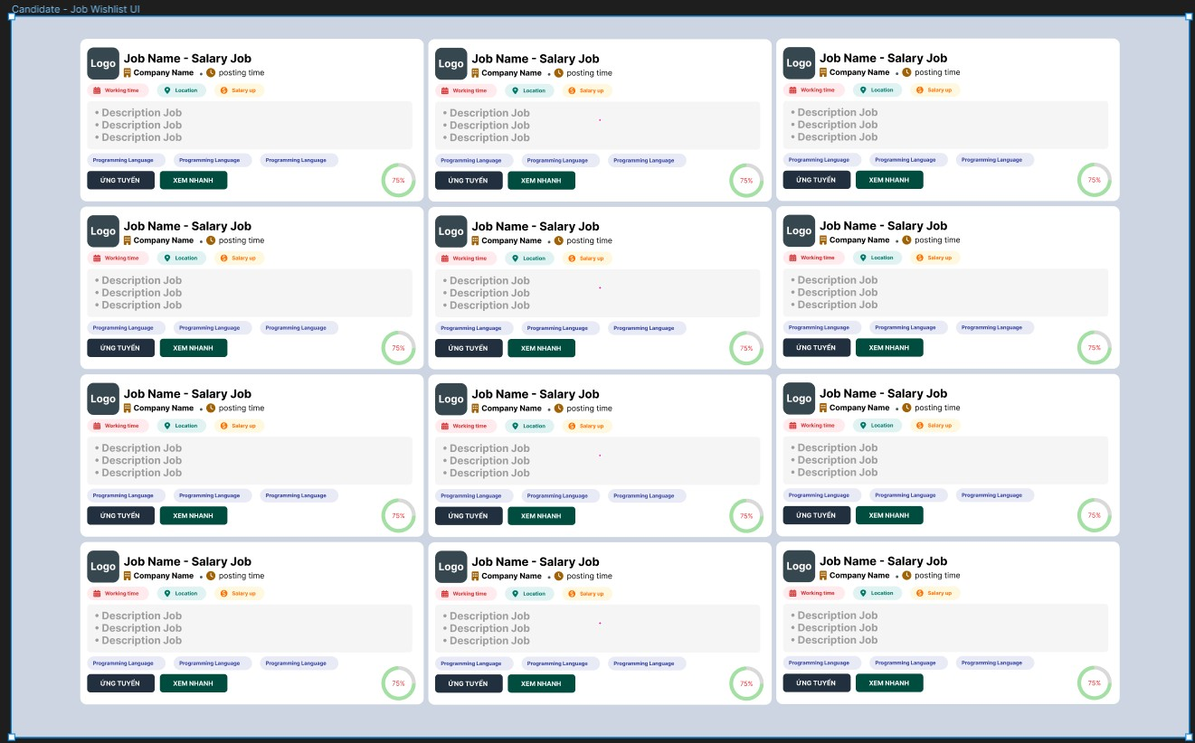

5

2

|  |  |  |  |  |
| --- | --- | --- | --- | --- |
| **ID** | **Condition** | **Control Type** | **Target** | **Notes** |
| 1 | Nothing | List | List Job |  |
| 2 | Click | Hyperlink | Job |  |

* + 1. **UI-10: Message UI**

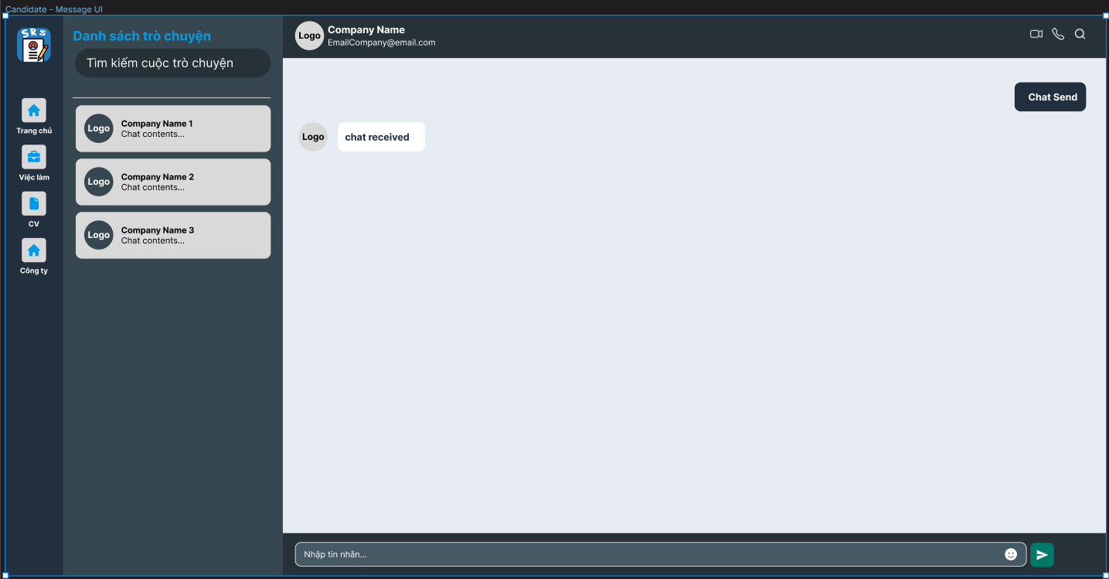

6

2

1

|  |  |  |
| --- | --- | --- |
| 3 |  | 4 |
| 5 | | |

|  |  |  |  |  |
| --- | --- | --- | --- | --- |
| **ID** | **Condition** | **Control Type** | **Target** | **Notes** |
| 1 | Click | Button | Button to click on other pages |  |
| 2 | Click | Hyperlink | Other chat people |  |
| 3 | Nothing | Text, Picture | Chat person information |  |
| 4 | Click | Icon | Call |  |
| 5 | Nothing | Text | Message |  |
| 6 | Click | Input | Enter the message to send |  |

* + 1. **UI-11: Write CV Online UI**

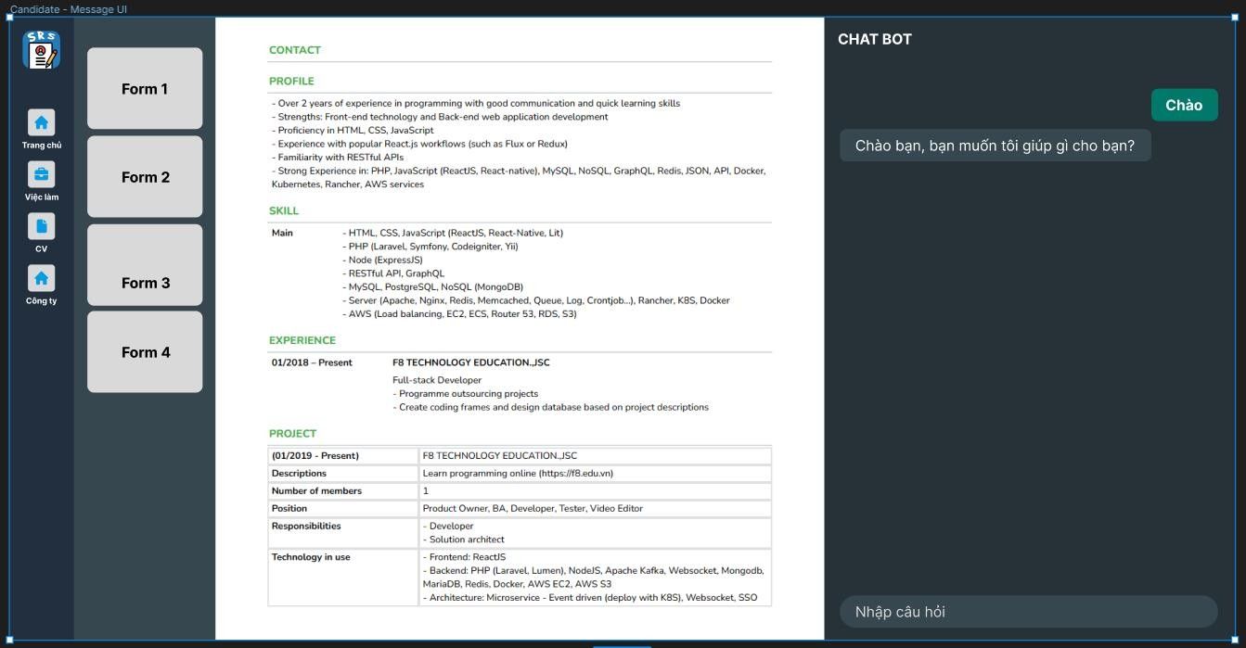

2

3

1

4

|  |  |  |  |  |
| --- | --- | --- | --- | --- |
| **ID** | **Condition** | **Control Type** | **Target** | **Notes** |
| 1 | Click | Picture | CV form |  |
| 2 | Click | Input | CV Input File |  |
| 3 | Nothing | Box Chat | Chat Bot |  |
| 4 | Click | Input | Input Chat |  |

* + 1. **UI-12 Register Candidate UI**

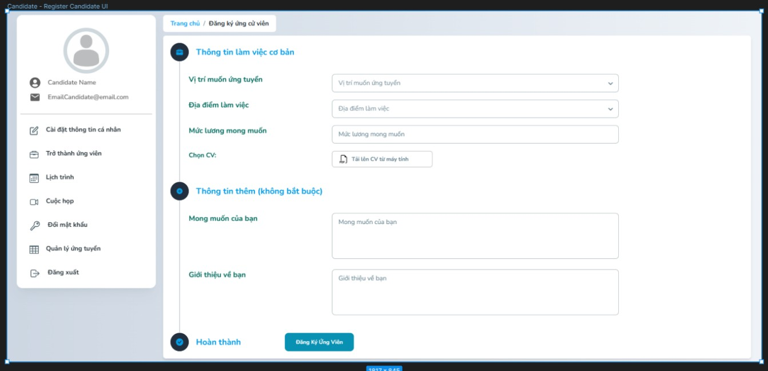

1

5

4

3

2

|  |  |  |  |  |
| --- | --- | --- | --- | --- |
| **ID** | **Condition** | **Control Type** | **Target** | **Notes** |
| 1 | Nothing | Form | Form Register Candidate |  |
| 2 | Click | Combo box | Choose Position & Location |  |
| 3 | Click | Input | Choose CV |  |
| 4 | Click | Input | Input Introduction and your wishes |  |
| 5 | Click | Button | Register as a candidate |  |

* + 1. **UI-13 Apply Management UI**

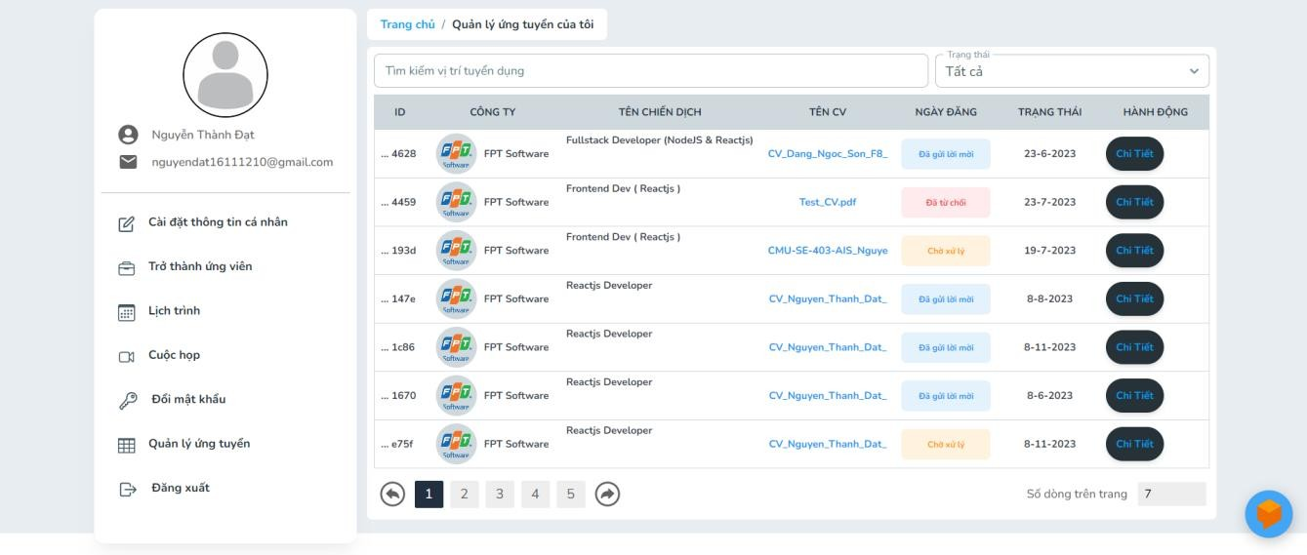

2

4

3

1

|  |  |  |  |  |
| --- | --- | --- | --- | --- |
| **ID** | **Condition** | **Control Type** | **Target** | **Notes** |
| 1 | Click | Input | Filter Job |  |
| 2 | Nothing | Table | List Application |  |
| 3 | Nothing | List | Information Application |  |
| 4 | Click | Button | Application Details |  |

* 1. **UI - Employer**
     1. **UI-01 Dashboard UI**

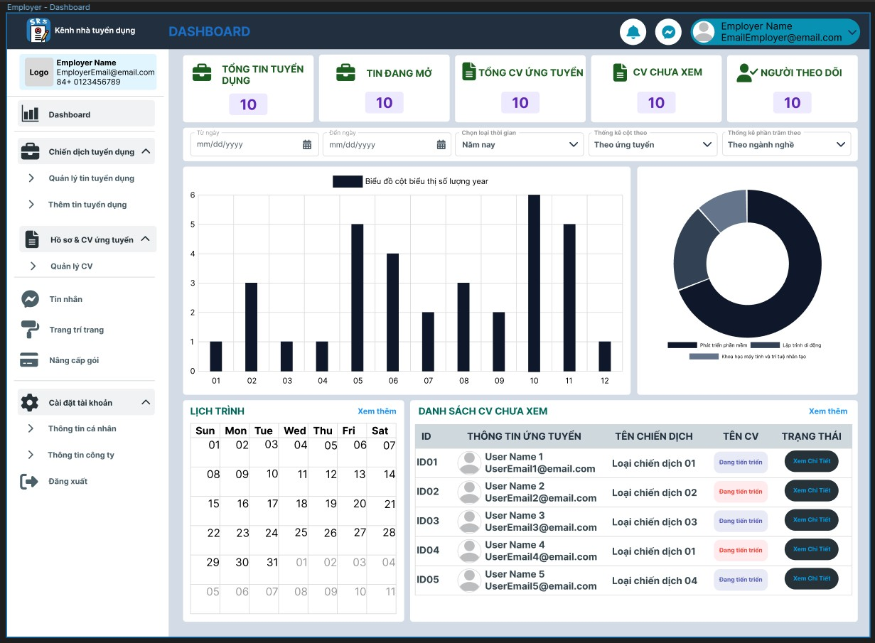

1

|  |  |  |  |
| --- | --- | --- | --- |
| 2 | | | |
| 3 | | | |
| 4 | | 5 | |
| 6 | 7 | |  |

|  |  |  |  |  |
| --- | --- | --- | --- | --- |
| **ID** | **Condition** | **Control Type** | **Target** | **Notes** |
| 1 | Click | List | Tool Bar |  |
| 2 | Nothing | List | Total statistics |  |
| 3 | Click | Input | Filter |  |
| 4 | Nothing | Chart | Column chart |  |

|  |  |  |  |  |
| --- | --- | --- | --- | --- |
| 5 | Nothing | Chart | Pie chart |  |
| 6 | Click | Form | Schedule |  |
| 7 | Click | Table | List of CVs that have not been viewed yet |  |

* + 1. 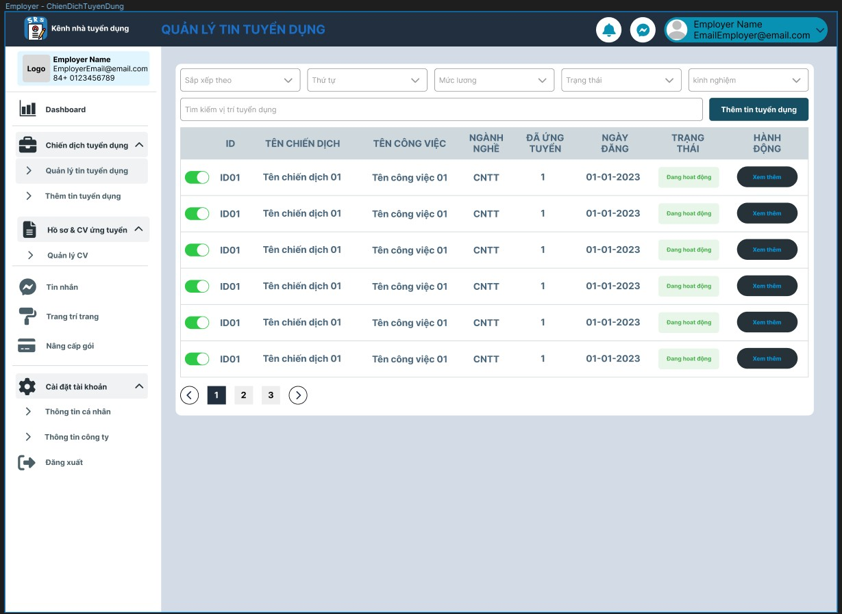**UI-02 Job Management UI**

|  |  |  |  |  |
| --- | --- | --- | --- | --- |
| 1 | | | | |
| 2 | | | | 3 |
| 4 | | | | |
| 5 | 6 | 7 |  | |

|  |  |  |  |  |
| --- | --- | --- | --- | --- |
| **ID** | **Condition** | **Control Type** | **Target** | **Notes** |
| 1 | Click | Combo box | Filter |  |
| 2 | Click | Input | Search for vacancies |  |
| 3 | Click | Button | Add vacancies |  |
| 4 | Nothing | Table | Recruitment list |  |
| 5 | Click | Link | Backward |  |
| 6 | Click | Hyperlink | Page Number |  |
| 7 | Click | Link | Forward |  |

* + 1. 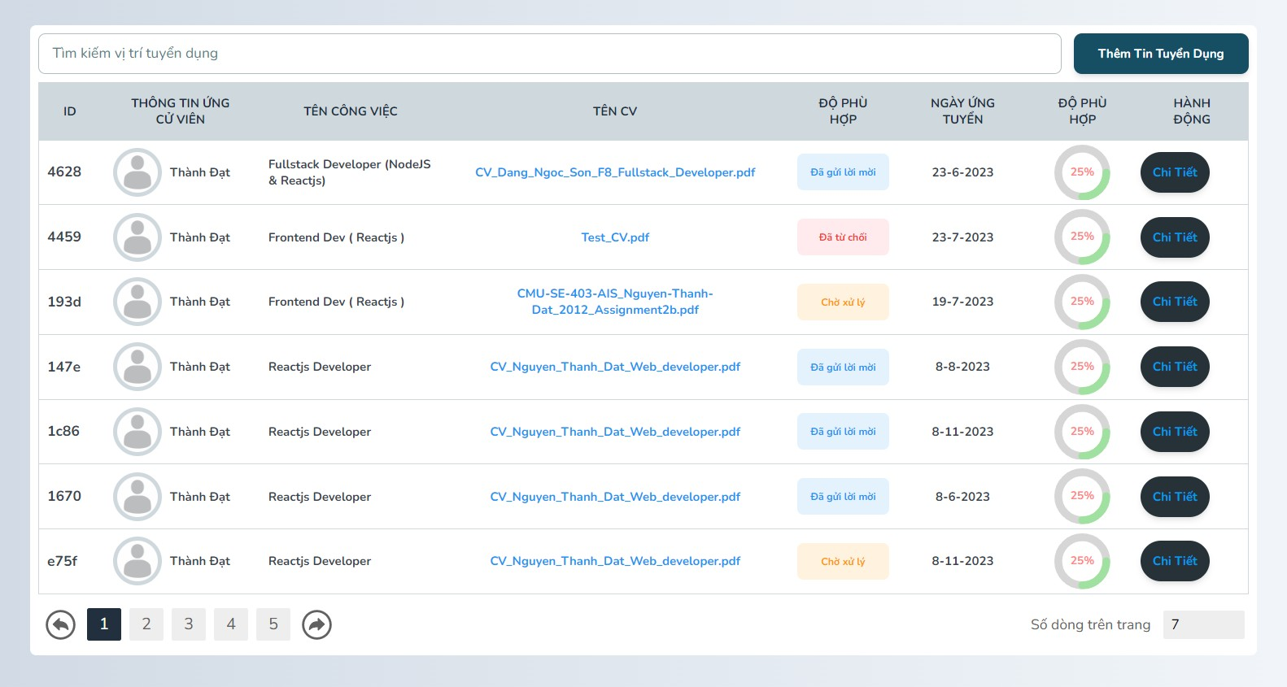**UI-03 CV & Candidate Management UI**

|  |  |  |  |
| --- | --- | --- | --- |
| 1 | | 2 | |
| 3 | | | |
| 4 | 5 | | 6 |
|  | | | |

|  |  |  |  |  |
| --- | --- | --- | --- | --- |
| **ID** | **Condition** | **Control Type** | **Target** | **Notes** |
| 1 | Click | Input | Search for vacancies |  |
| 2 | Click | Input | Add vacancies |  |
| 3 | Nothing | Table | List CV & Candidate |  |
| 4 | Nothing | List | Information CV & Candidate |  |
| 5 | Nothing | Chart | CV & Candidate suitability |  |
| 6 | Click | Button | CV & Candidate Details |  |

* + 1. **UI-04 Schedule UI**

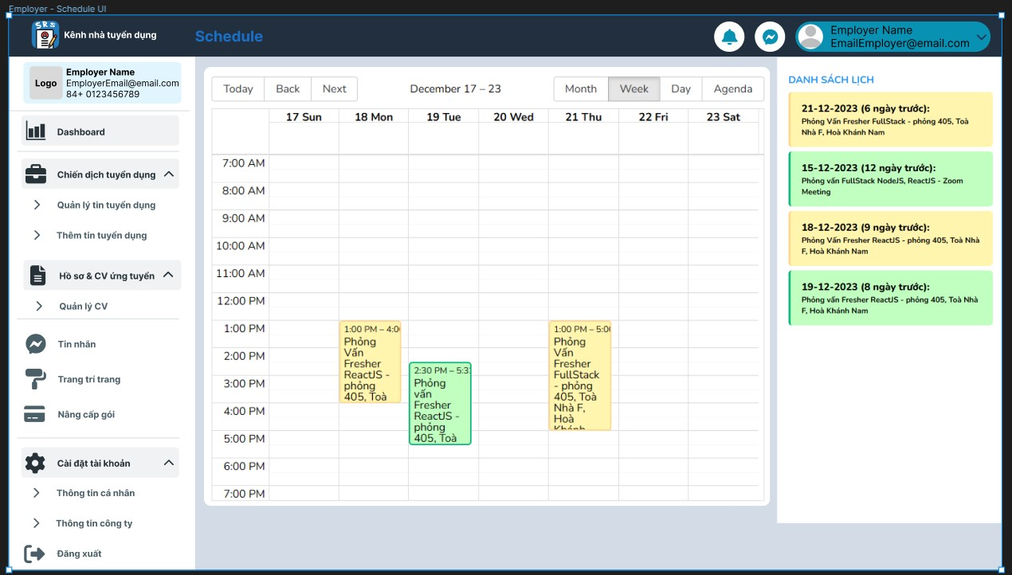

2

1

|  |  |  |  |  |
| --- | --- | --- | --- | --- |
| **ID** | **Condition** | **Control Type** | **Target** | **Notes** |
| 1 | Nothing | Table | Schedule Details |  |
| 2 | Nothing | List | List Schedule |  |

* + 1. 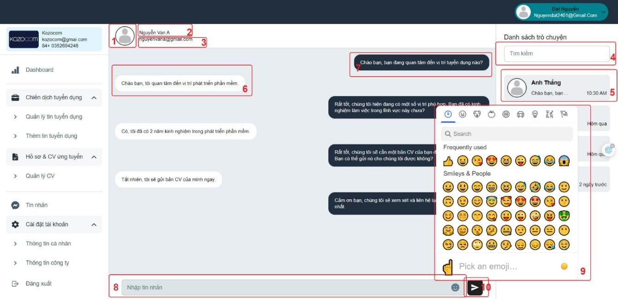**UI-05 Message UI**

|  |  |  |  |  |
| --- | --- | --- | --- | --- |
| **ID** | **Condition** | **Control Type** | **Target** | **Notes** |
| 1 | Nothing | Image | Avatar |  |
| 2 | Nothing | Label | Chat person's name |  |
| 3 | Nothing | Label | Chat person's Email |  |
| 4 | Click | Input | Search Chat |  |
| 5 | Click | Button | Chat Person |  |
| 6 | Nothing | Label | Message from the sender |  |
| 7 | Nothing | Label | Your Messenger |  |
| 8 | Click | Input | Message composition content |  |
| 9 | Click | Button | Emoji |  |
| 10 | Click | Button | Send Message |  |

* + 1. **UI-07 Upgrade Recruitment Package UI**

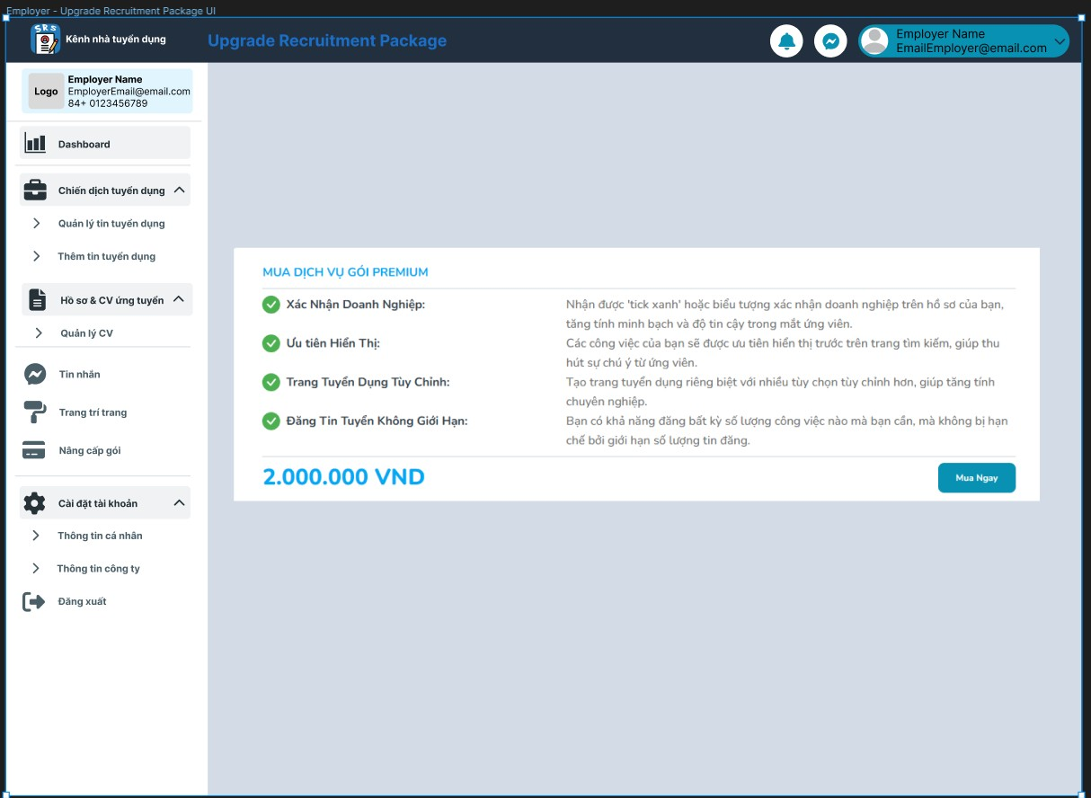

1

2

|  |  |  |  |  |
| --- | --- | --- | --- | --- |
| **ID** | **Condition** | **Control Type** | **Target** | **Notes** |
| 1 | Nothing | Text | Description Premium Package |  |
| 2 | Click | Button | Buy Premium Package |  |

* + 1. 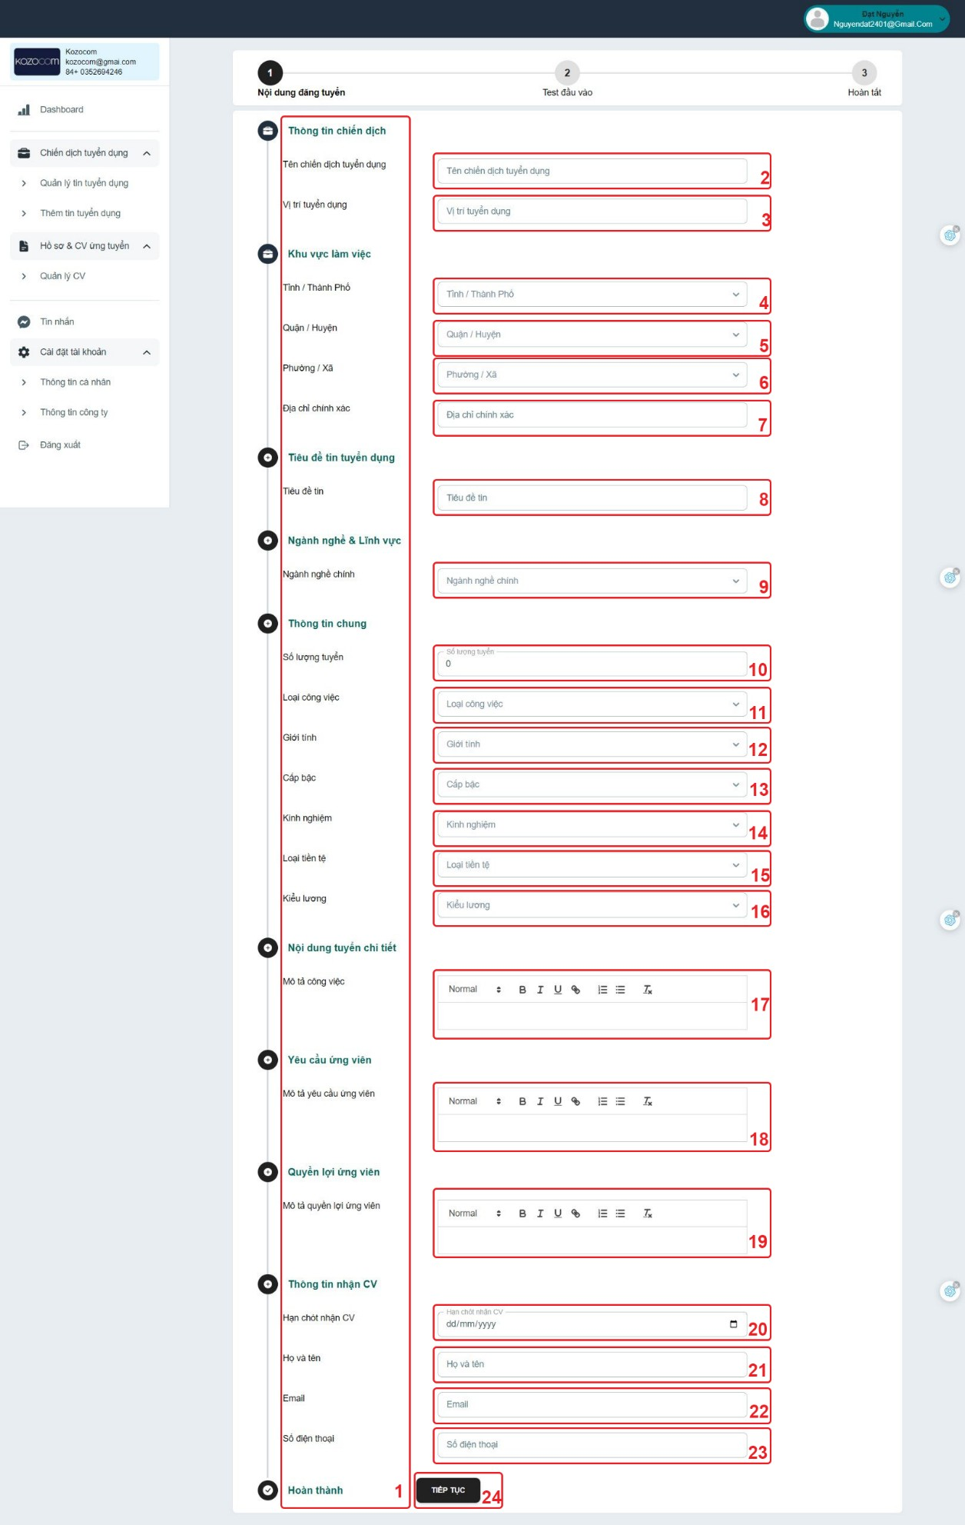**UI-08 Profile Management UI**

|  |  |  |  |  |
| --- | --- | --- | --- | --- |
| **ID** | **Condition** | **Control Type** | **Target** | **Notes** |
| 1 | Nothing | Label | Label Information Description |  |
| 2 | Click | Input | Input Recruitment campaign name |  |
| 3 | Click | Input | Input Vacancies |  |
| 4 | Click | Input | Input Province/City |  |
| 5 | Click | Input | Input District/District |  |
| 6 | Click | Input | Input Ward Commune |  |
| 7 | Click | Input | Input Correct address |  |
| 8 | Click | Input | Input News title |  |
| 9 | Click | Input | Input Main industry |  |
| 10 | Click | Input | Input Number of Recruitment |  |
| 11 | Click | Input | Input Job Type |  |
| 12 | Click | Input | Gender Input |  |
| 13 | Click | Input | Input Rank |  |
| 14 | Click | Input | Input Experience |  |
| 15 | Click | Input | Input Currency |  |
| 16 | Click | Input | Salary Type Input |  |
| 17 | Click | Input | Input Job Description |  |
| 18 | Click | Input | Input Description of Candidate Requirements |  |
| 19 | Nothing | Input | Input Description of Candidate Benefits |  |
| 20 | Click | Input | Input CV Deadline |  |
| 21 | Click | Input | Input Full Name |  |
| 22 | Click | Input | Input Email |  |

|  |  |  |  |  |
| --- | --- | --- | --- | --- |
| 23 | Click | Input | Input Phone Number |  |
| 24 | Click | Button | Button Continue |  |

* 1. **UI - Admin**
     1. **UI-01 Dashboard UI**

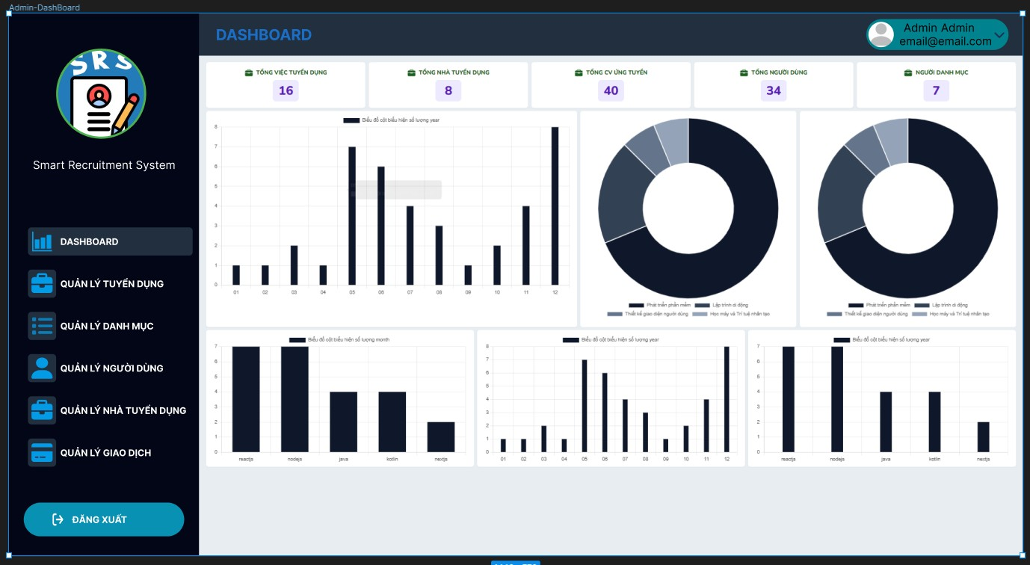

2

1

|  |  |  |  |  |
| --- | --- | --- | --- | --- |
| **ID** | **Condition** | **Control Type** | **Target** | **Notes** |
| 1 | Nothing | List | Total statistics |  |
| 2 | Nothing | Chart | Chart |  |

* + 1. 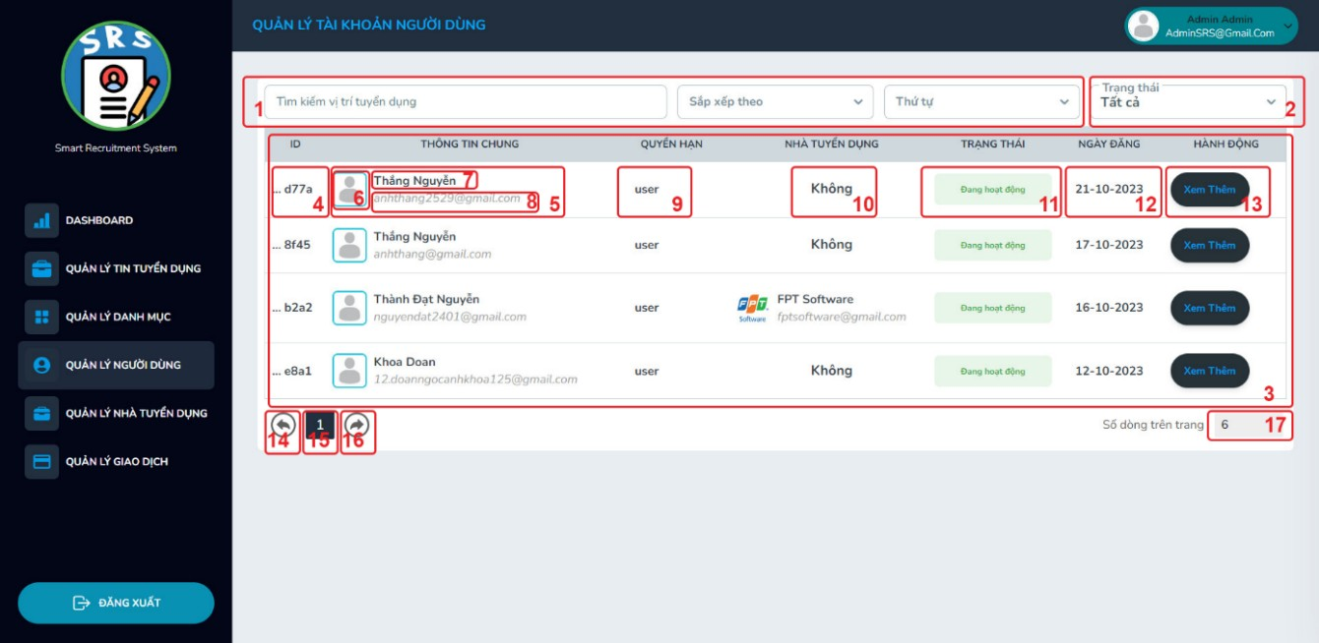**Account Management UI**

|  |  |  |  |  |
| --- | --- | --- | --- | --- |
| **ID** | **Condition** | **Control Type** | **Target** | **Notes** |
| 1 | Click | Input | Filter |  |
| 2 | Click | Input | Status Candidate Management |  |
| 3 | Nothing | Table | Candidate list |  |
| 4 | Nothing | Label | ID Candidate |  |
| 5 | Nothing | Table | Account Candidate |  |
| 6 | Nothing | Image | Image Account Candidate |  |
| 7 | Nothing | Label | Name Account Candidate |  |
| 8 | Nothing | Label | Email Account Candidate |  |
| 9 | Nothing | Label | Candidate's powers |  |
| 10 | Nothing | Label | Employer Name |  |
| 11 | Nothing | Label | Candidate Status |  |
| 12 | Nothing | Label | Candidate posting date |  |
| 13 | Click | Button | Candidate See more |  |
| 14 | Click | Button | Backward |  |

|  |  |  |  |  |
| --- | --- | --- | --- | --- |
| 15 | Click | Button | Page Number |  |
| 16 | Click | Button | Forward |  |
| 17 | Click | Input | Line number displayed |  |

* + 1. 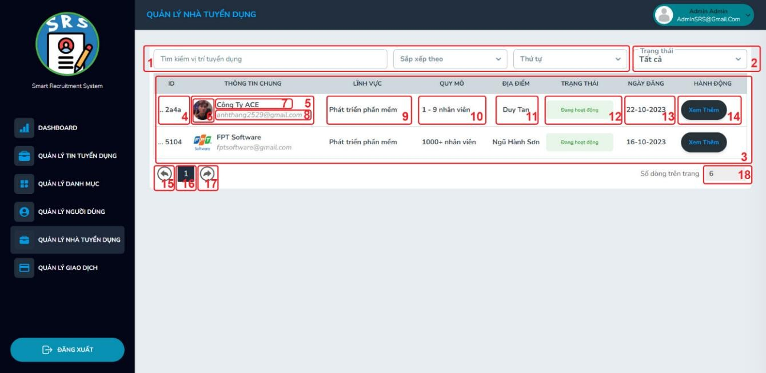**Employer Management UI**

|  |  |  |  |  |
| --- | --- | --- | --- | --- |
| **ID** | **Condition** | **Control Type** | **Target** | **Notes** |
| 1 | Click | Input | Filter |  |
| 2 | Click | Input | Status Employer Management |  |
| 3 | Nothing | Table | Employer list |  |
| 4 | Nothing | Label | ID Employer |  |
| 5 | Nothing | Table | Account Employer |  |
| 6 | Nothing | Image | Image Account Employer |  |
| 7 | Nothing | Label | Name Account Employer |  |
| 8 | Nothing | Label | Email Account Employer |  |
| 9 | Nothing | Label | Employer Field |  |

|  |  |  |  |  |
| --- | --- | --- | --- | --- |
| 10 | Nothing | Label | Employer Scale |  |
| 11 | Nothing | Label | Employer Location |  |
| 12 | Nothing | Label | Employer Status |  |
| 13 | Nothing | Label | Employer posting date |  |
| 14 | Click | Button | Employer See more |  |
| 15 | Click | Button | Backward |  |
| 16 | Click | Button | Page Number |  |
| 17 | Click | Button | Forward |  |
| 18 | Click | Input | Line number displayed |  |

* + 1. 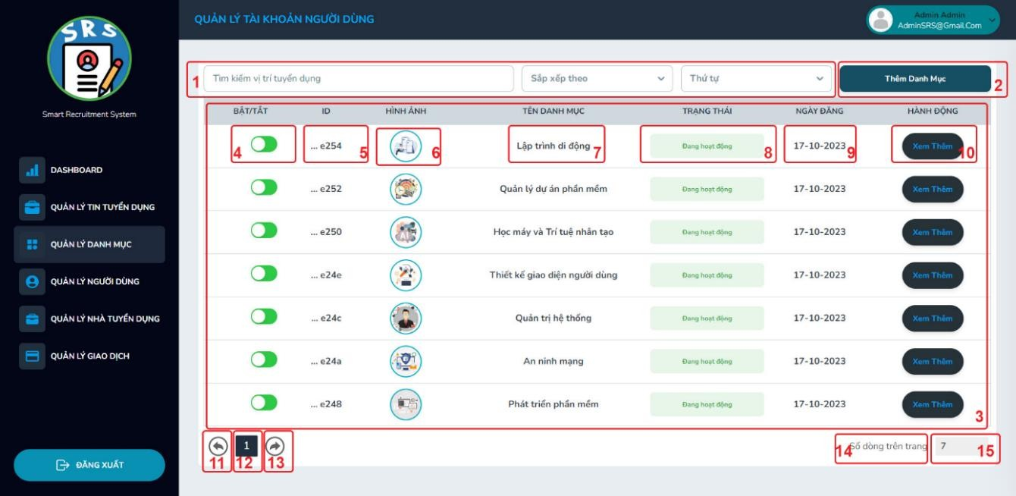**Category Management UI**

|  |  |  |  |  |
| --- | --- | --- | --- | --- |
| **ID** | **Condition** | **Control Type** | **Target** | **Notes** |
| 1 | Click | Input | Filter |  |
| 2 | Click | Button | Button to add categories to the list |  |
| 3 | Nothing | Table | Category list |  |
| 4 | Click | Button | Turn categories off and on |  |
| 5 | Nothing | Label | ID Category |  |
| 6 | Nothing | Image | Image Category |  |
| 7 | Nothing | Label | Name Category |  |
| 8 | Nothing | Label | Category Status |  |
| 9 | Nothing | Label | Category posting date |  |

|  |  |  |  |  |
| --- | --- | --- | --- | --- |
| 10 | Click | Button | Category See more |  |
| 11 | Click | Button | Backward |  |
| 12 | Click | Button | Page Number |  |
| 13 | Click | Button | Forward |  |
| 14 | Nothing | Label | Description Page Number |  |
| 15 | Click | Input | Line number displayed |  |

* + 1. 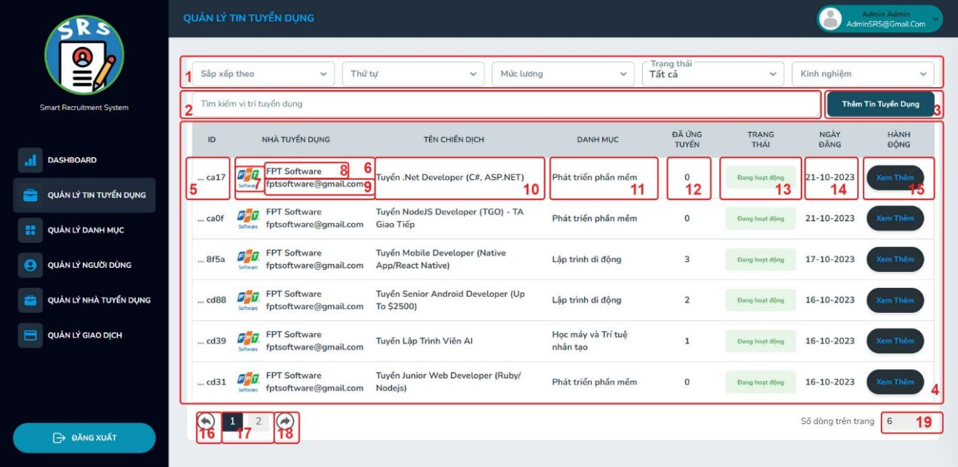**Job Management UI**

|  |  |  |  |  |
| --- | --- | --- | --- | --- |
| **ID** | **Condition** | **Control Type** | **Target** | **Notes** |
| 1 | Click | Input | Filter |  |
| 2 | Click | Input | Search for vacancies |  |

|  |  |  |  |  |
| --- | --- | --- | --- | --- |
| 3 | Click | Button | Add recruitment news |  |
| 4 | Nothing | Table | Job list |  |
| 5 | Nothing | Label | ID Job |  |
| 6 | Nothing | Table | Job Account Employer |  |
| 7 | Nothing | Image | Image Account Employer |  |
| 8 | Nothing | Label | Name Account Employer |  |
| 9 | Nothing | Label | Email Account Employer |  |
| 10 | Nothing | Label | Name of recruitment campaign |  |
| 11 | Nothing | Label | Category |  |
| 12 | Nothing | Label | Number who applied for the job |  |
| 13 | Nothing | Label | Job Status |  |
| 14 | Nothing | Label | Job posting date |  |
| 15 | Click | Button | Job See more |  |
| 16 | Click | Button | Backward |  |
| 17 | Click | Button | Page Number |  |

|  |  |  |  |  |
| --- | --- | --- | --- | --- |
| 18 | Click | Button | Forward |  |
| 19 | Click | Input | Line number displayed |  |

# **2.4 UI – Chatbot**

## **2.4.1 Train NLU Data**

|  |  |  |  |  |
| --- | --- | --- | --- | --- |
| **ID** | **Condition** | **Control Type** | **Target** | **Notes** |
| 1 | Click | Input | Search example |  |
| 2 | Click | Button | Button to add example to the list |  |
| 3 | Click | Table | Add example and intent |  |
| 4 | Nothing | Button | Example list |  |
| 5 | Nothing | Label | Intent |  |
| 6 | Nothing | Label | Edit and delete example |  |

## **2.4.2 Train Stories Data**

|  |  |  |  |  |
| --- | --- | --- | --- | --- |
| **ID** | **Condition** | **Control Type** | **Target** | **Notes** |
| 1 | Click | Input | Filter |  |
| 2 | Click | Button | Button to add stories to the list |  |
| 3 | Nothing | Label | Show categories stories |  |
| 4 | Nothing | Label | Intent name |  |
| 5 | Nothing | Label | Stories list |  |
| 6 | Nothing | Label | Edit and delete intent |  |
| 7 | Nothing | Label | Stories flow |  |

## **2.4.3 Admin Chatbot Interface**

|  |  |  |  |  |
| --- | --- | --- | --- | --- |
| **ID** | **Condition** | **Control Type** | **Target** | **Notes** |
| 1 | Click | Input | Search conversation |  |
| 2 | Nothing | Label | User name and email |  |
| 3 | Nothing | Label | User name |  |
| 4 | Nothing | Label | Content of the conversation |  |
| 5 | Click | Input | Enter answer |  |
| 6 | Click | Label | Submit your answer |  |

## **2.4.4 User interface with chatbot**

|  |  |  |  |  |
| --- | --- | --- | --- | --- |
| **ID** | **Condition** | **Control Type** | **Target** | **Notes** |
| 1 | Nothing | Label | System chatbot name |  |
| 2 | Nothing | Label | Content of the conversation |  |
| 3 | Click | Input | Enter answer |  |
| 4 | Click | Input | Submit your answer |  |

## **2.4.5 Train Domain**

|  |  |  |  |  |
| --- | --- | --- | --- | --- |
| **ID** | **Condition** | **Control Type** | **Target** | **Notes** |
| 1 | Nothing | Label | Domain list |  |
| 2 | Click | Button | Save domain |  |

## **2.4.6 Train Response**

|  |  |  |  |  |
| --- | --- | --- | --- | --- |
| **ID** | **Condition** | **Control Type** | **Target** | **Notes** |
| 1 | Click | Input | Search response |  |
| 2 | Click | Button | Add response |  |
| 3 | Click | Input | Create or select an utter, add a response to this form |  |
| 4 | Click | Button | Save or destroy the response for the corresponding utter |  |
| 5 | Nothing | Label | Utter list |  |
| 6 | Nothing | Label | Response list |  |